WEB PHISHING DETECTI0N

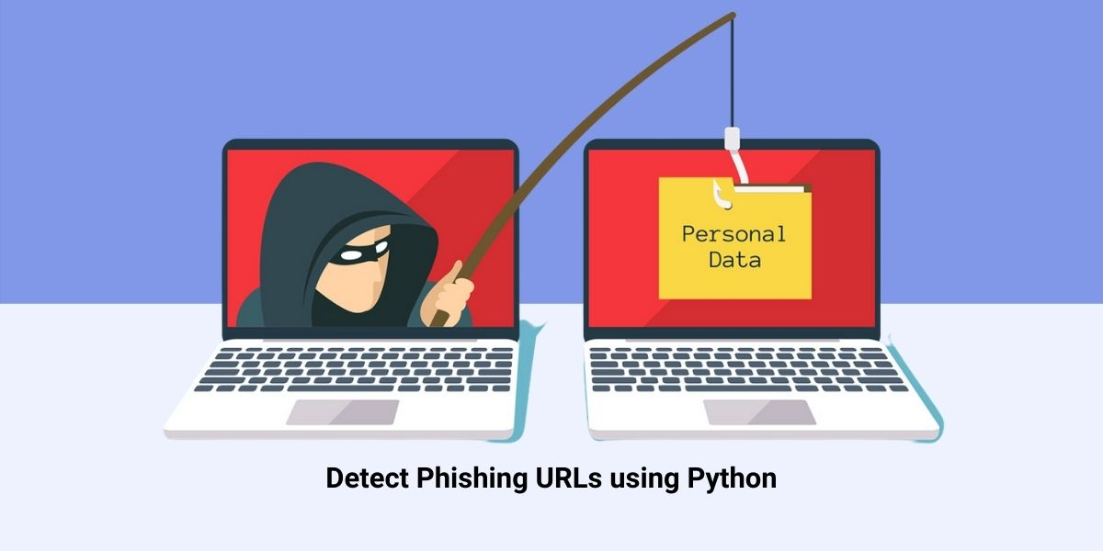

PROBLEM STATEMENT

*TEAM DETAILS*

*TEAM NUMBER : PNT2022TMID34399*

*COLLEGE NAME : CAPE INSTITUTE OF TECHNOLOGY*

*DEPARTMENT : INFORMATION TECHNOLOGY*

TEAM MEMBERS

|  |  |
| --- | --- |
| TEAM MEMBER POSITION | MEMBER NAME |
| TEAM LEADER | A.ISWARYA |
| TEAM MEMBER 1 | T.PARVATHY |
| TEAM MEMBER 2 | T.SALINI |
| TEAM MEMBER 3 | A.SAHAYA ABISHA |



PROBLEM STATEMENT

|  |  |
| --- | --- |
| DATE | 22/10/22 |
| PROJECT NAME | WEB PHISHING DETECTION |

Phishing is a fraudulent technique that uses social and technological tricks to steal customer identification and financial credentials. Social media systems use spoofed e-mails from legitimate companies and agencies to enable users to use fake websites to divulge financial details like usernames and passwords. Hackers install malicious software on computers to steal credentials, often using systems to intercept username and passwords of consumers’ online accounts. Phishers use multiple methods, including email, Uniform Resource Locators (URL), instant messages, forum postings, telephone calls, and text messages to steal user information. The structure of phishing content is similar to the original content and trick users to access the content in order to obtain their sensitive data. The primary objective of phishing is to gain certain personal information for financial gain or use of identity theft. Phishing attacks are causing severe economic damage around the world. Moreover, Most phishing attacks target financial/payment institutions and webmail, according to the Anti-Phishing Working Group (APWG) latest Phishing pattern studies

|  |  |  |  |  |  |
| --- | --- | --- | --- | --- | --- |
| Problem Statement (PS) | I am | I’m trying to | But | Because | Which makes me feel |
| PS-1 | Internet user | Browse the internet | I identify a scam | An attacker masquerades as a reputable entity | Unsafe about my information that is shared over the network |
| PS-2 | Enterprise user | Open emails in the cloud server | I detect malicious protocols | They are not cryptographically signed. | Emails are unverified and third party intrusion |

